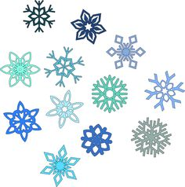
Theme: Snow Flakes
Outcome: N1.1
N1.1 Say the number sequence, 0 to 100 by: 1s forward and backward between any two given numbers, 2s to 20, forward starting at 0, 5s and 10s to 100, forward starting at 0.
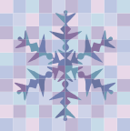 Learning Goals:
- Forward counting and Backward counting
- Skip counting by twos, fives and tens
- Identify and correct the errors in counting
- Understanding numbers tell how much or how many things are in a set
- Counting in sequence
- Learn a variety of counting strategies both concrete (pictorial and symbolic including: Counting by fives and tens)
- Understanding there are many ways to represent a single quantity
Task/Problem Question:
- Select one number from 0-100 and represent it with snowflakes?
Alternatives:
- How can you represent 80 with groups of 2, 5 or 10? Choose one.
- Select one number and show me how you can skip count by twos, fives and tens?
What strategy did you use to represent? How many groups do you see? How many groups of twos are there? Are there any groups of 5s? Do you see any groups of 10s? If you change the arrangement do you still see the same number? Can you tell me a different way of seeing it?
Anticipation:
- How might the student solve it?
- Skip counting.
- Skip counting by twos
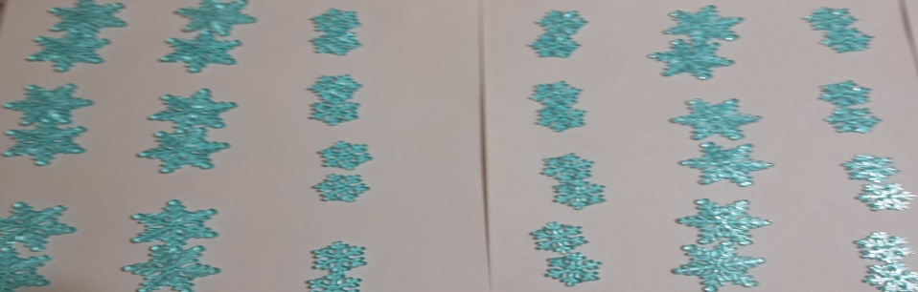

Questions to ask: What are you counting by? How are you doing it? Why are you doing it? What does it tell you? How did you get there?
- Using five frames
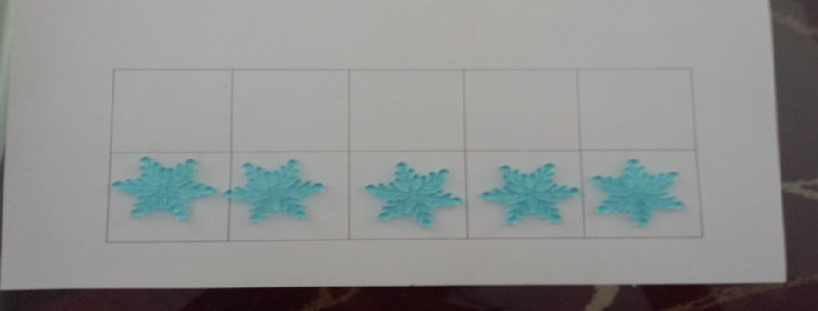

Questions to ask: What are you counting by? How are you doing it? Why are you doing it? What does it tell you? How did you get there?
- Using tens frames
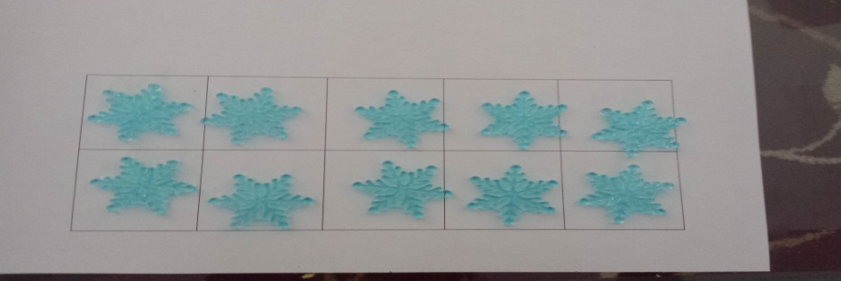

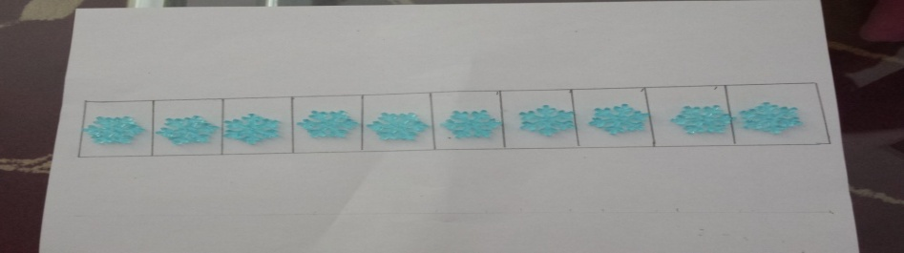
Questions to ask: What are you counting by? How are you doing it? Why are you doing it? What does it tell you? How did you get there?

- Counting by groups of twos, fives and tens.
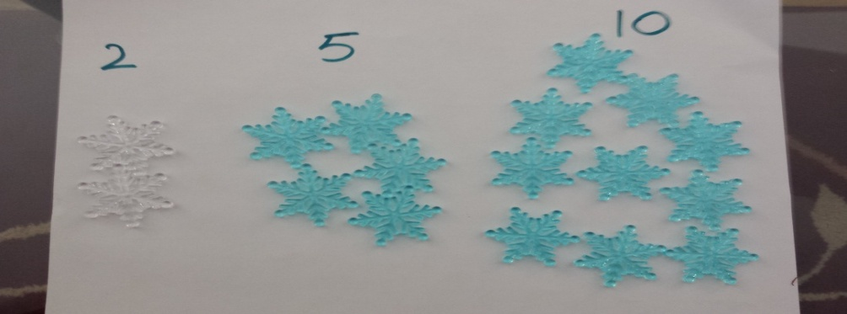

Questions to ask: Can you show me how you made groups of twos, fives and tens on a 100 chart. Can you explain how did you skip count? How did you get to 100? Do you see any pattern in twos, fives and tens?
- Skip-counting by patterns.
- Counting by colours.
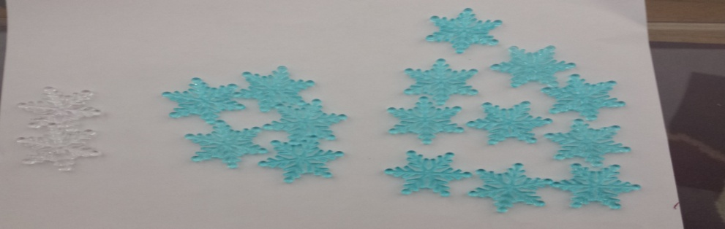
Questions to ask: How did you know there is pattern in colors? How did you count? What does it tell you? If you rearrange the colourful stars does the number will be same?
- Forward counting and backward counting on a 100 chart.
- Can identify and correct the error and omissions in counting.
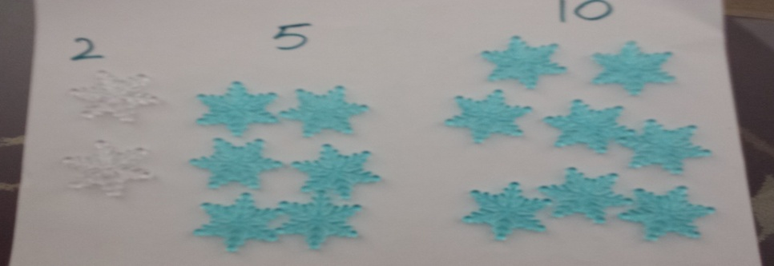
Questions to ask: Does it make a difference when you count backwards or frontwards? How did you count? What does it tell you? How do you count in a sequence? If you go backwards from 100 to 0, does it make any difference?
- Can represent the numeral symbolically.
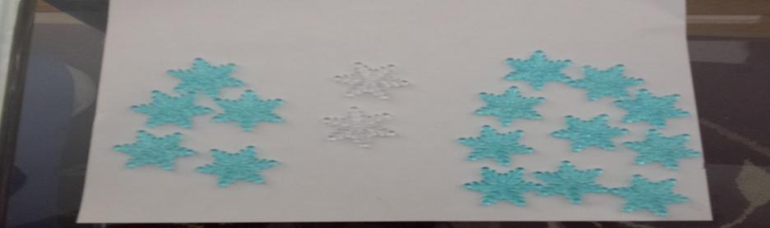
Questions to ask: How did you find the error? How did you know that this numeral represents the snowflakes? How strategy did you use to count snowflakes? What does it tell you? If you rearrange it does the numeral change?
- Anticipation of errors:
- Might confuse counting of twos. Instead of saying 12, 14, 16, 18, 200 will say like 12, 15, 17, 18 etc.
Questions to ask: Can you show me how you counted 12, 15, 17, and 18.
- Errors in counting e.g. counting from38, 39, and 40 will say 38, 39, and 31.
Questions to ask: Can you show me how you counted 38, 39, and 31.
- Errors in counting by fives. Instead of saying 45, 50, 55, 60, the student will say like 45, 47, 50, 55, 57, and 60.
Questions to ask: Can you show me how you counted by fives. Do you see any pattern in it?
- Errors in counting by tens. Instead of saying 10, 20, 30, 40, 50, student will say 10, 20, 33, 41 and 51.
Questions to ask: Can you show me how you counted by tens? Is there any pattern in tens?
- Got mixed up counting and started 2, 5, 10, 12, and 14.
Questions to ask: Can you show me how you counted this? Are you counting by twos, fives or tens can you explain. Teacher will clarify how twos, fives and tens pattern work.
Monitoring:
Counting
0-100
Skip Counting

Skip counting-fives frames
Skip counting-
tens frames
Groups of twos, fives and tens
Counting in a pattern
Identify errors in number sequence
Can represent the numeral symbolically
Other comments:
Students understand that the last number spoken signifies how many numbers in the set.
As an educator I understand that the larger quantities can no longer be managed at a glance.

Selecting and Sequencing:
- Start with the counting from 0-100 frontwards.
- Clarify students that in frontwards and backwards counting, quantity remains the same.
- Counting with objects like snowflakes.
- Look for groupings like groups of two, fives, tens, skip counting.
- Patterns in skip counting.
Connections:
- How does Aamina’s work relate to what Ben did?
- How is the counting related to it and why?
- What are some of the strategies used and how?
- How colours are related to the pattern?
- How skip counting has a pattern? Do you see any pattern in skip counting?
- What do groups of twos, fives and tens have to do with counting?

