
Theme: Snow Flakes
Outcome: N1.2
Recognize, at a glance, and name familiar arrangements of 1 to 10 objects, dots, or pictures.


Learning Goals:
- To determine how many in a group.
- Learn a variety of ways to count the numbers.
- To develop basic math skill of counting mentally.
Task/Problem Question:
- Can you identify how many snowflakes are there in the box without counting?
Alternatives:
- Can you tell me how many dots on the paper? How can you tell that?
How many do you see? How do you know that? How do you there are 10? If I change the arrangement do you still see 10? Can you tell me a different way of seeing 10?
Anticipation:
- How might the student solve it?
- Visualizing the numbers in order
- From 0 to 10
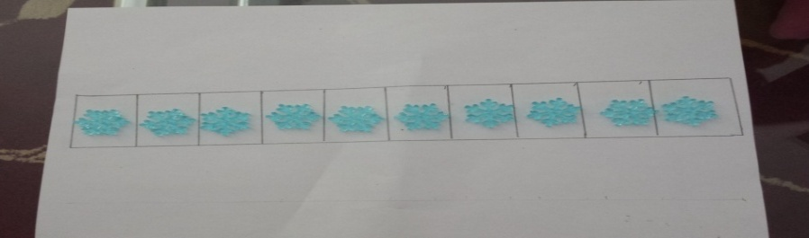
Questions to ask: How did you know the order of numbers? How did you come up with your answer? What does it tell you?
ii. Arrangement of snowflakes in a pattern like one big one small snowflake.
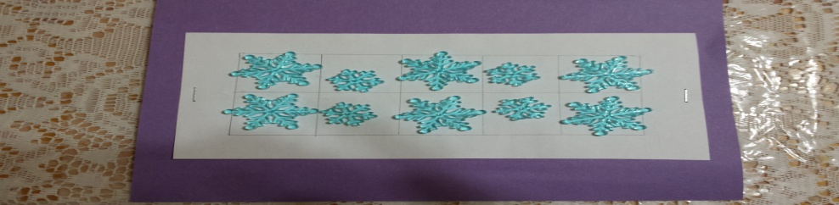
Questions to ask: How do you see there are 10? How did you come up with your answer? Does it tell you about pattern, how can you show that?
iii. Students might of snowflakes in a pattern of colors.
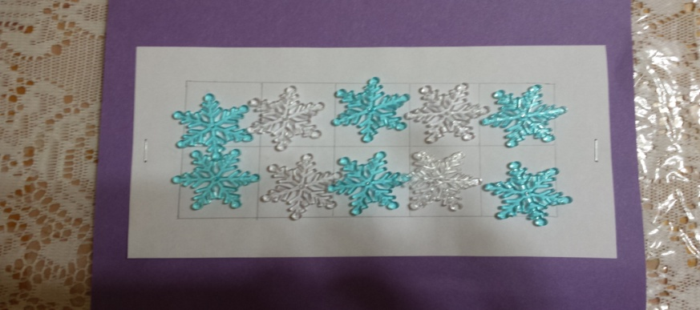
Questions to ask: How do you see there are 10 in total? Do you see two different groups? How did you come up with thinking a pattern like that?
- Creating subgroups. Groups of two.
- 5 groups of 2 snowflakes.
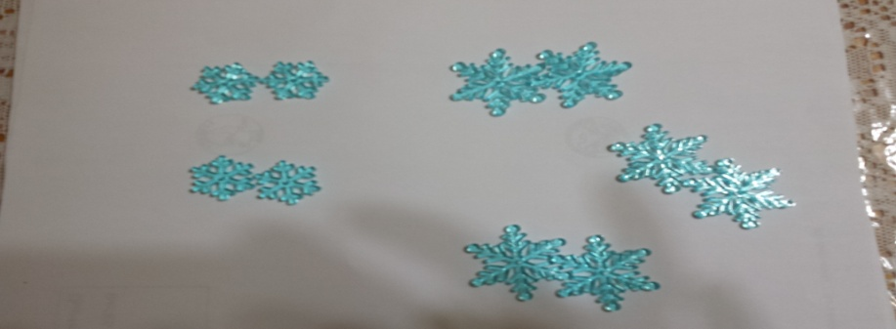
Questions to ask: Show me how did you do that? How can you think of groups like that? How 2 snowflakes in each group make 10? Did you think of any other object while doing numbers in your head?
- Student might think like 2 groups of 3 snowflakes and 2 groups of 2 snowflakes.
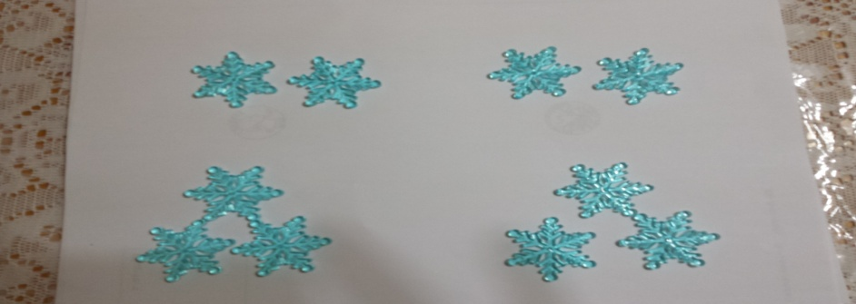
Questions to ask: How can you think of two different sizes of groups? Why 1 cannot be in the same group? Does it make a big difference? Does it affect the numbers in order? Did you think of any object thinking about the numbers in your head?
- One big group and one small.
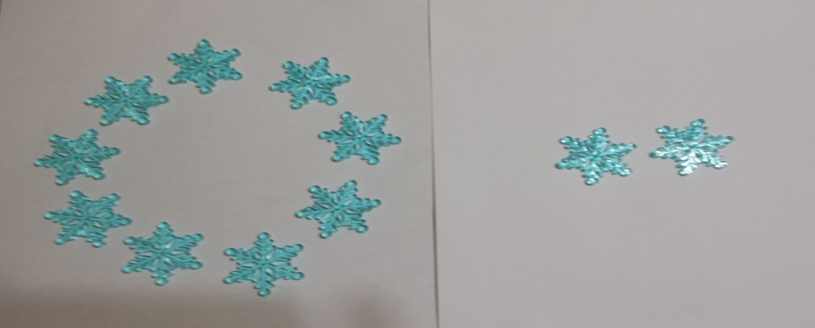
Questions to ask: Can you think of any other way to represent 10? How are you doing it? Why are you doing it? What does it tell you about the groups? How did you recognize it? How did you determine the size of small group?
Students who struggle with basic skills can do:
c. Counting at their fingers or with the help of an object. They can say the numbers while touching the object.
- Closing each finger while counting mentally.
Questions to ask: Does counting on fingers make sense to you? How many fingers do you have in one hand? Did you start counting from your thumb?
- One snow flake, two snowflakes …..
Questions to ask: How can you count the snowflakes together? Do you count them one at a time? Anticipation of errors:
- Might get confused while counting. Instead of thinking 1, 2, 3 can think of 1, 3, 2
Questions to ask: Can you count for me starting from 0.
- Errors in order like 1, 2, 3, 4, 5, 7, 6, 8, 9, and 10.
Questions to ask: Can you show me with the help of the object how did you put the numbers in that order?
- Errors like “I saw 2 groups of two black dots and 3 groups of two pink dots and that makes 9”.
Questions to ask: Can you show me how it makes 9?
- Errors in quantity like 8 snowflakes instead of 10.
Questions to ask: Ok now let’s count together and see how many it makes?
- Confusion in associating snowflakes with numerals and say 10 numbers and snowflakes.
Questions to ask: Show me how numbers are different from the object. I would say 10 fingers and I wouldn’t say 10 number and fingers, now it’s your turn can you count the snowflakes and tell me how many are they?
Monitoring:
Recognizing how many in a group
Identify group size
Visualizing a pattern
Looking at it in a different way
Associating the objects with numbers
Can name the pattern
Other comments:
This can be related to grouping them in the classroom. Make two groups of 5 and then ask how many people will work together on one table? Or may be during Gym make groups of 5 to play one game and another group of 5 to play another game and then switch their games. Ask them how many students are playing in groups’ altogether?
Selecting and Sequencing:
- Start to count verbally
- Thinking of numbers from small to big
- Making groups or sets of objects.
- Looking for pattern in groups.
- Comparison of groups.
Connections:
- How does Ali’s work relate to what Abby did?
- What are some of the strategies you could use to show the numbers counted?
- What do groups have to do with counting?
- How does a number of a group tell you that how many are there in total?
- How pattern is related to counting?

