
Theme: Snowflakes
Outcome: N1.3
N1.3 Demonstrate an understanding of counting by:
• indicating that the last number said identifies “how many”; showing that any set has only one count; using the counting on strategy; using parts or equal groups to count sets.

Learning Goals:
- Applying counting principles to count
- Forward counting
- Backward counting 
- Skip counting
- Counting by groups
Task/Problem Question:
- If you move 50 snowflakes to a new design, will the quantity change?
Alternatives:
- If you start counting the set of snowflakes from the other side, do you think, will it change the quantity or not?
Anticipation:
- How might the student solve it?

- Count to identify the number of the set.
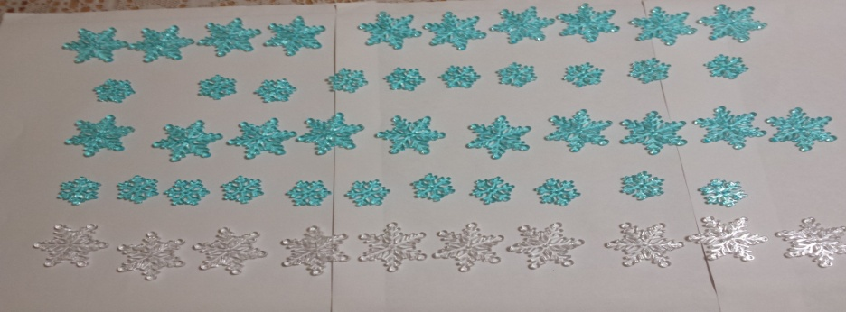
Questions to ask: How did you know the number of the group? How did you count the total number? What does it tell you? Does it make any change when you are counting from either side?

- Creating sub groups to tell the total number in a big group
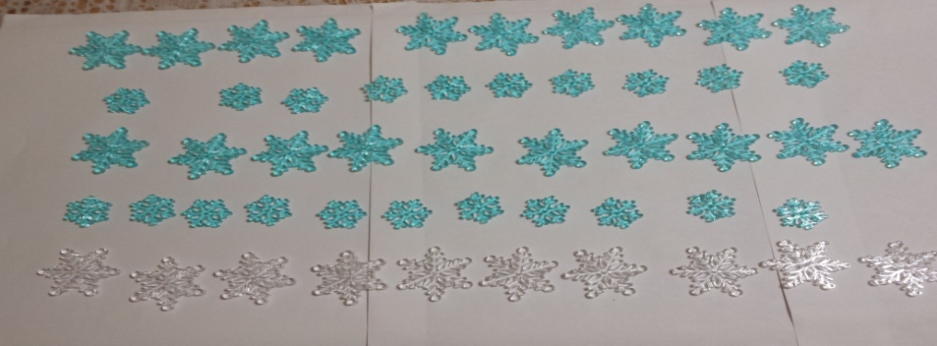
Questions to ask: How many are there in this group? How did you create subgroups? How do you know 10 groups of 5 will make 50? What does it tell you? Does it make any change when you are counting from either side?
- Skip Counting
- Skip counting of snowflakes by twos
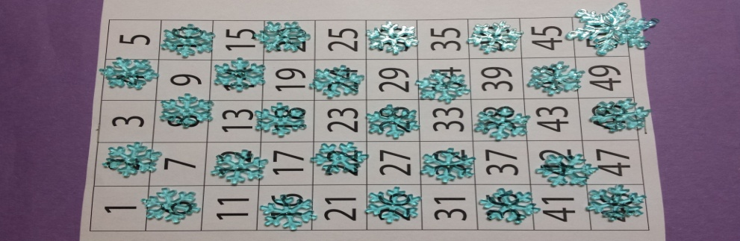
Questions to ask: How many groups of two will make 24? How did you create subgroups? What about backward counting? Will it change the total number?
- Skip counting of snowflakes by fives
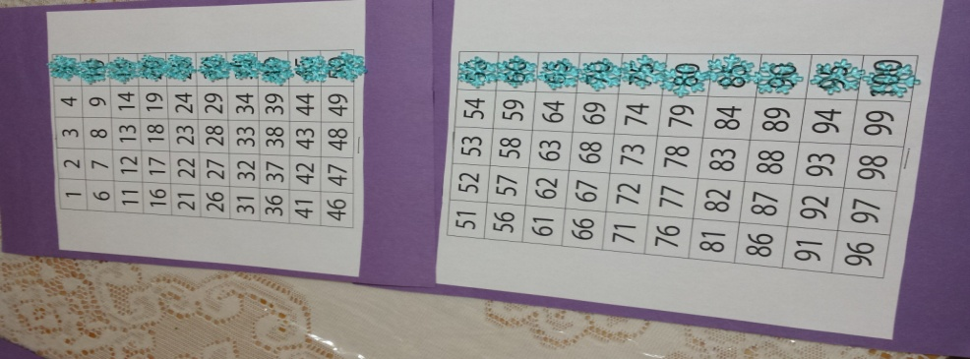
Questions to ask: How many groups of fives will make 55? How did you create subgroups? What strategy did you use?

- Skip counting of snowflakes by tens
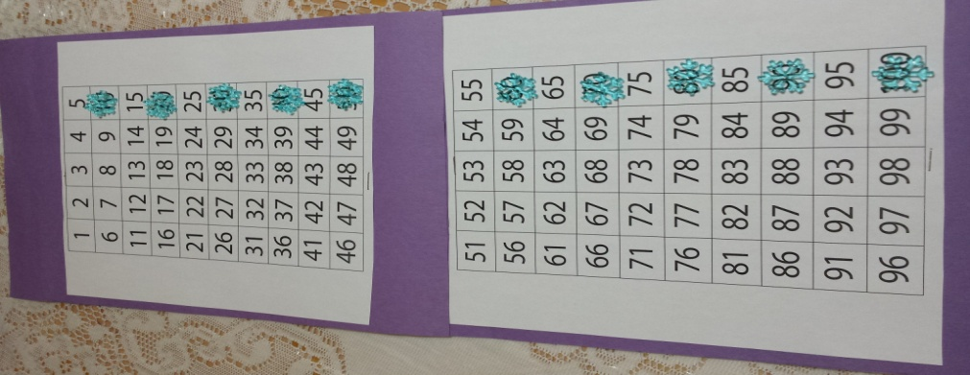
Questions to ask: How many groups of ten will make 70? How did you make subgroups? Does the small group make the counting easier?
- Skip counting of snowflakes by tens and ones

Questions to ask: How many groups of tens and ones will make 11? What is the difference in the groups? Which group do you think has more? If you make five groups of 10 and one group has only one how much it will make in total? If you count forward does it make difference? If you count backward do the numbers change?
- Anticipation of errors:

- Might confuse counting in order. Instead of saying 41, 42, 43, 44, 45, 46, 47, 48, 49, 50 will say like 41, 42, 44, 43, 45, 47, 48, 49, 50
Questions to ask: Can you show me how you counted from 41- 50
- Errors in counting by fives. Instead of saying 45, 50, 55, 60, the student will say like 45, 47, 50, 55, 57, and 60.
Questions to ask: Can you show me how you counted by fives. Do you see any pattern in it?
- Errors in counting by tens. Instead of saying 10, 20, 30, 40, 50, student will say 10, 20, 33, 41 and 51.
Questions to ask: Can you show me how you counted by tens? Is there any pattern in tens?
- Got mixed up while counting backward 10, 9, 8, 7, 6, 5, 4, 3, 2, and 1 and started 10, 9, 6, 7, and 8.
Questions to ask: Can you show me how did you count in backward order? Is there any pattern in backward counting? Does it make any difference in the total number?
- Mixed up counting when asked to count by tens and ones.
Questions to ask: Which is the group of ten and where is one? How many they make if we count altogether? Does dividing them in groups make a difference?
Monitoring:
What is the total number: “how many” in the group
Identify group size
Count the numbers in every group
Correct the number if there is any error
Skip counting by 2s, 5s, 10s
Other comments:
There are different ways to count till 100. Students can understand that counting backward, forward, skip counting by 2s, 5, 10s, does not change the total number.
Selecting and Sequencing:
- Counting in an order
- Relationship between subgroups while counting
- Remember the sequence in counting
- Pattern in colour of happy rocks
Connections:
- How Jenna counted the snowflakes differently than Bill did?
- What are some of the strategies used and how?
- What do groups have to do with counting?
- How changing of the sequence does not affect the total number?
- What is the relation of subgroups to the total number?
- Does the changing colour of the snowflakes make a difference on total number?



