OUTCOME:
N4.7 Demonstrate an understanding of decimal numbers in tenths and hundredths (pictorially, orally, in writing, and symbolically) by: • describing • representing • relating to fractions.

LEARNING GOALS:
- Learn a variety of ways in which decimal numbers in tenths and hundredths can be represented.
- Make the connection that money can be used to represent decimal numbers in tenths and hundredths.
- Decimals can be thought about in terms of fractions.
- Grocery prices are everyday examples in which tenths and hundreds are used.
TASK 1:
Select an item from one of the grocery flyers. Cut it out and glue it onto a piece of cardstock. Select a way(s) to represent the price of your chosen item.

ANTICIPATION:
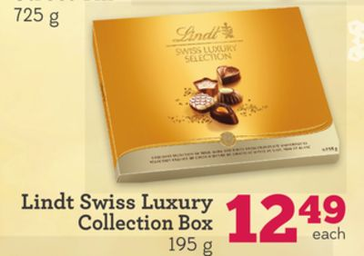
EXAMPLE

- How might the students represent the price?
  - Orally
    - “Twelve and forty-nine hundredths”
    - “Twelve dollars and forty-nine cents”
Questions to ask: How do you know that is the way to orally represent the price of the item? If they orally represent it as i., ask if they can orally represent it in the form of money, ii. And vice versa.
  - In Writing
    - Twelve and forty-nine hundredths
    - Twelve dollars and forty-nine cents
Questions to ask: How do you know that is the way to represent the price of the item in writing? If they represent it as i., ask if they can represent it in the form of money, ii. And vice versa.
  - Symbolically
    - Standard Form
12.49
$12.49
    - Expanded From
10 + 2 + 0.40 + 0.09

    - Place Value Chart
Tens | Ones | Tenths | Hundredths
1 | 2 | 4 | 9
Questions to ask: How do you know which numeral goes where? How do you know where the decimal goes? How does place value help you to correctly represent the price symbolically?
  - Concretely
    - Manipulate base ten blocks
    - Manipulate coins/money
*Note: Students may choose to round up or down since the Penny/1cent coin is no longer in circulation in Canada.
Questions to ask: How does manipulating a tangible help you to better understand the representation of the item’s price? How does money/coins represent the price?
  - Pictorially
    - Draw out base ten model
Tens Ones Tenths Hundredths
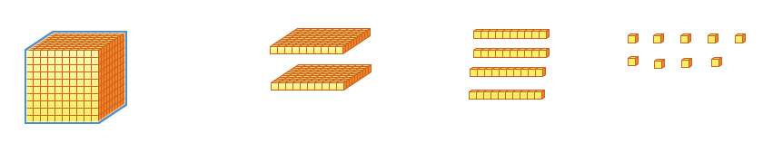
    - Draw corresponding coins/money
*Note: This will vary depending on the coins students chose to use.

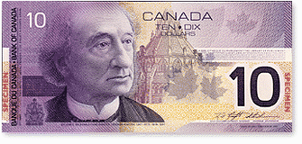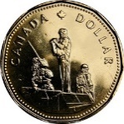

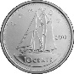

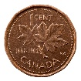

OR
*Note: Students may choose to round up or down since the Penny/1cent coin is no longer in circulation in Canada.

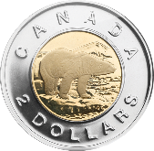

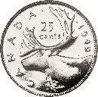

Questions to ask: How does a picture/drawing help you to better understand the representation of the item’s price? How does money/coins represent the price?

  - Fractions
    - Symbolically
  - 0.49 = 49/100
    - Pictorially: Shade squares on a hundred grid
  - 49 shaded squared on a hundred grid can be expressed as 0.49 or 49/100
Questions to ask: How do you know that decimals can be thought of in terms of fractions? Why did you chose a hundred grid over another type of grid? How is it connected to the price and money?

- Anticipation of errors
  - Error in oral delivery.
Questions to ask: Make sure they know the place value of each numeral. Ask how their oral delivery looks symbolically compared to the item price from the grocery flyer?
  - Error in writing representation.
Questions to ask: Make sure they know the place value of each numeral. Ask how their writing representation looks symbolically compared to the item price from the grocery flyer?
  - Error with place value or placement of decimal.
Questions to ask: What would your symbolic representation of the item price sound like if delivered orally or look like if written.
  - Confusion as to which base ten block represent which place value.
Questions to ask: Can you show me why you chose that particular base ten block to represent that place value? How would that compare to money/coins?
Error in rounding up or down because the Penny/1cent coin is no longer in circulation in Canada.
Questions to ask: Why did you round that way? How would considering the nickel/5cent coin help you be more precise in your rounding?
  - Confusion as to which base ten block represent which place value.
Questions to ask: Can you show me why you chose that particular base ten block to represent that place value? How would that compare to money/coins?
Error in rounding up or down because the Penny/1cent coin is no longer in circulation in Canada.
Questions to ask: Questions to ask: Why did you round that way? How would considering the nickel/5cent coin help you be more precise in your rounding?
  - Student’s symbolic or pictorial representation of the decimal in a fraction form is too abstract.
Questions to ask: How would knowing 100 pennies/1cent coins equal one dollar help with being specific with your denominator choice and pictorial grid choice?

MONITORING:
Orally
In Writing
Symbolically
Standard From
Expanded From
Place Value Chart
Other
Concretely (Manipulate)
Base Ten Blocks
Coins/Money
Other
Pictorially (Draw)
Base Ten Blocks
Coins/Money
Other
Fractions
Symbolically
Pictorially
Other
SELECTING AND SEQUENCING:
- Start with most common way students chose to represent the item price and move towards the least common way students chose to represent the item price.
- Or start with ways that you know students have used in other situations/past tasks.

CONNECTIONS:
After students have completed the task, have them share and compare their way(s) of representing the price of their grocery item with fellow classmates in pairs or small groups. Based on the entire class’s ways, determine the most common and discuss. Continue to discuss the various ways students chose to represent the price of their items, from most common to least.
Prompting Questions:
- How is ***’s representations similar and different to ***’s?
- How are decimal numbers in tenths and hundredths connected to money?
- How are decimals and fractions related?
- What other everyday examples contain tenths and hundreds?

