Math Themed Tasks
By: Willow Wallace-Lewis
Grade 5
Outcomes:
SS5.2
SS5.1
SS5.5

Theme:
Constructing a town as a class!

Content: (Topic)  This is Lesson I of a three part lesson in which the students will construct a 2D town on large sheets of graphing paper through using mathematical instructions. | Instructional Strategies: (Specific)  -Circulate  -Ask guiding questions  -Encourage dialogue between peers and pairs
Outcomes:  Outcome: SS5.2  Demonstrate understanding of measuring length (mm) by:  - selecting and justifying referents for the unit mm  - modelling and describing the relationship between mm, cm, and m units. | Indicators:  d. Draw, construct, or physically act out a representation of a given linear measurement (e.g., the students might be asked to show 4 m; this could be done by drawing a straight line on the board that is 4 m in length, constructing a box (or different boxes) that has a base with a perimeter of 4 m, or carrying out a physical movement that results in moving 4 m).
Prerequisite Learning:
•Familiarity with measurement and how to use a ruler/metre stick
•Spatial awareness

Preparation: (Equipment/materials/set-up)
•Rulers (each student should have one)
•Metre sticks (about 5)
•Large sheets of graphing paper (52cmx80cm)
•Instruction sheets for each pair (see attached)
•Stop signs/speed bumps/trees for each pair (sheets/see attached)
*There will be a compass (drawn) set in the middle of the paper so the students will know which direction to draw their roads.

*Desks will be pushed back to the walls so there is a large empty space in the centre of the classroom, there will be several sheets of graphing paper laid out on the floor (number 1 through 10 so they can be cleared and laid out again on following days). The pieces of graphing paper will be split up into 10 sections and the students will be paired into placed into of 2 or 3 and each assigned a section.

Set (5 min)  -Place the students into pairs/groups of 3  -Hand them each a worksheet with instructions for their section (1-10)  -Have them find their section and begin plotting their roads  Development (30 min)  -Have students working in their pairs and together to plot their roads on the graph paper (**See attached student instructions)  Closure (5 min)  -Have class stand back and look over the roads that they have plotted, is there anything they want to change? How does it look? | Student Engagement/Classroom Management Strategies  -Circulate to ensure everyone understands/is on task

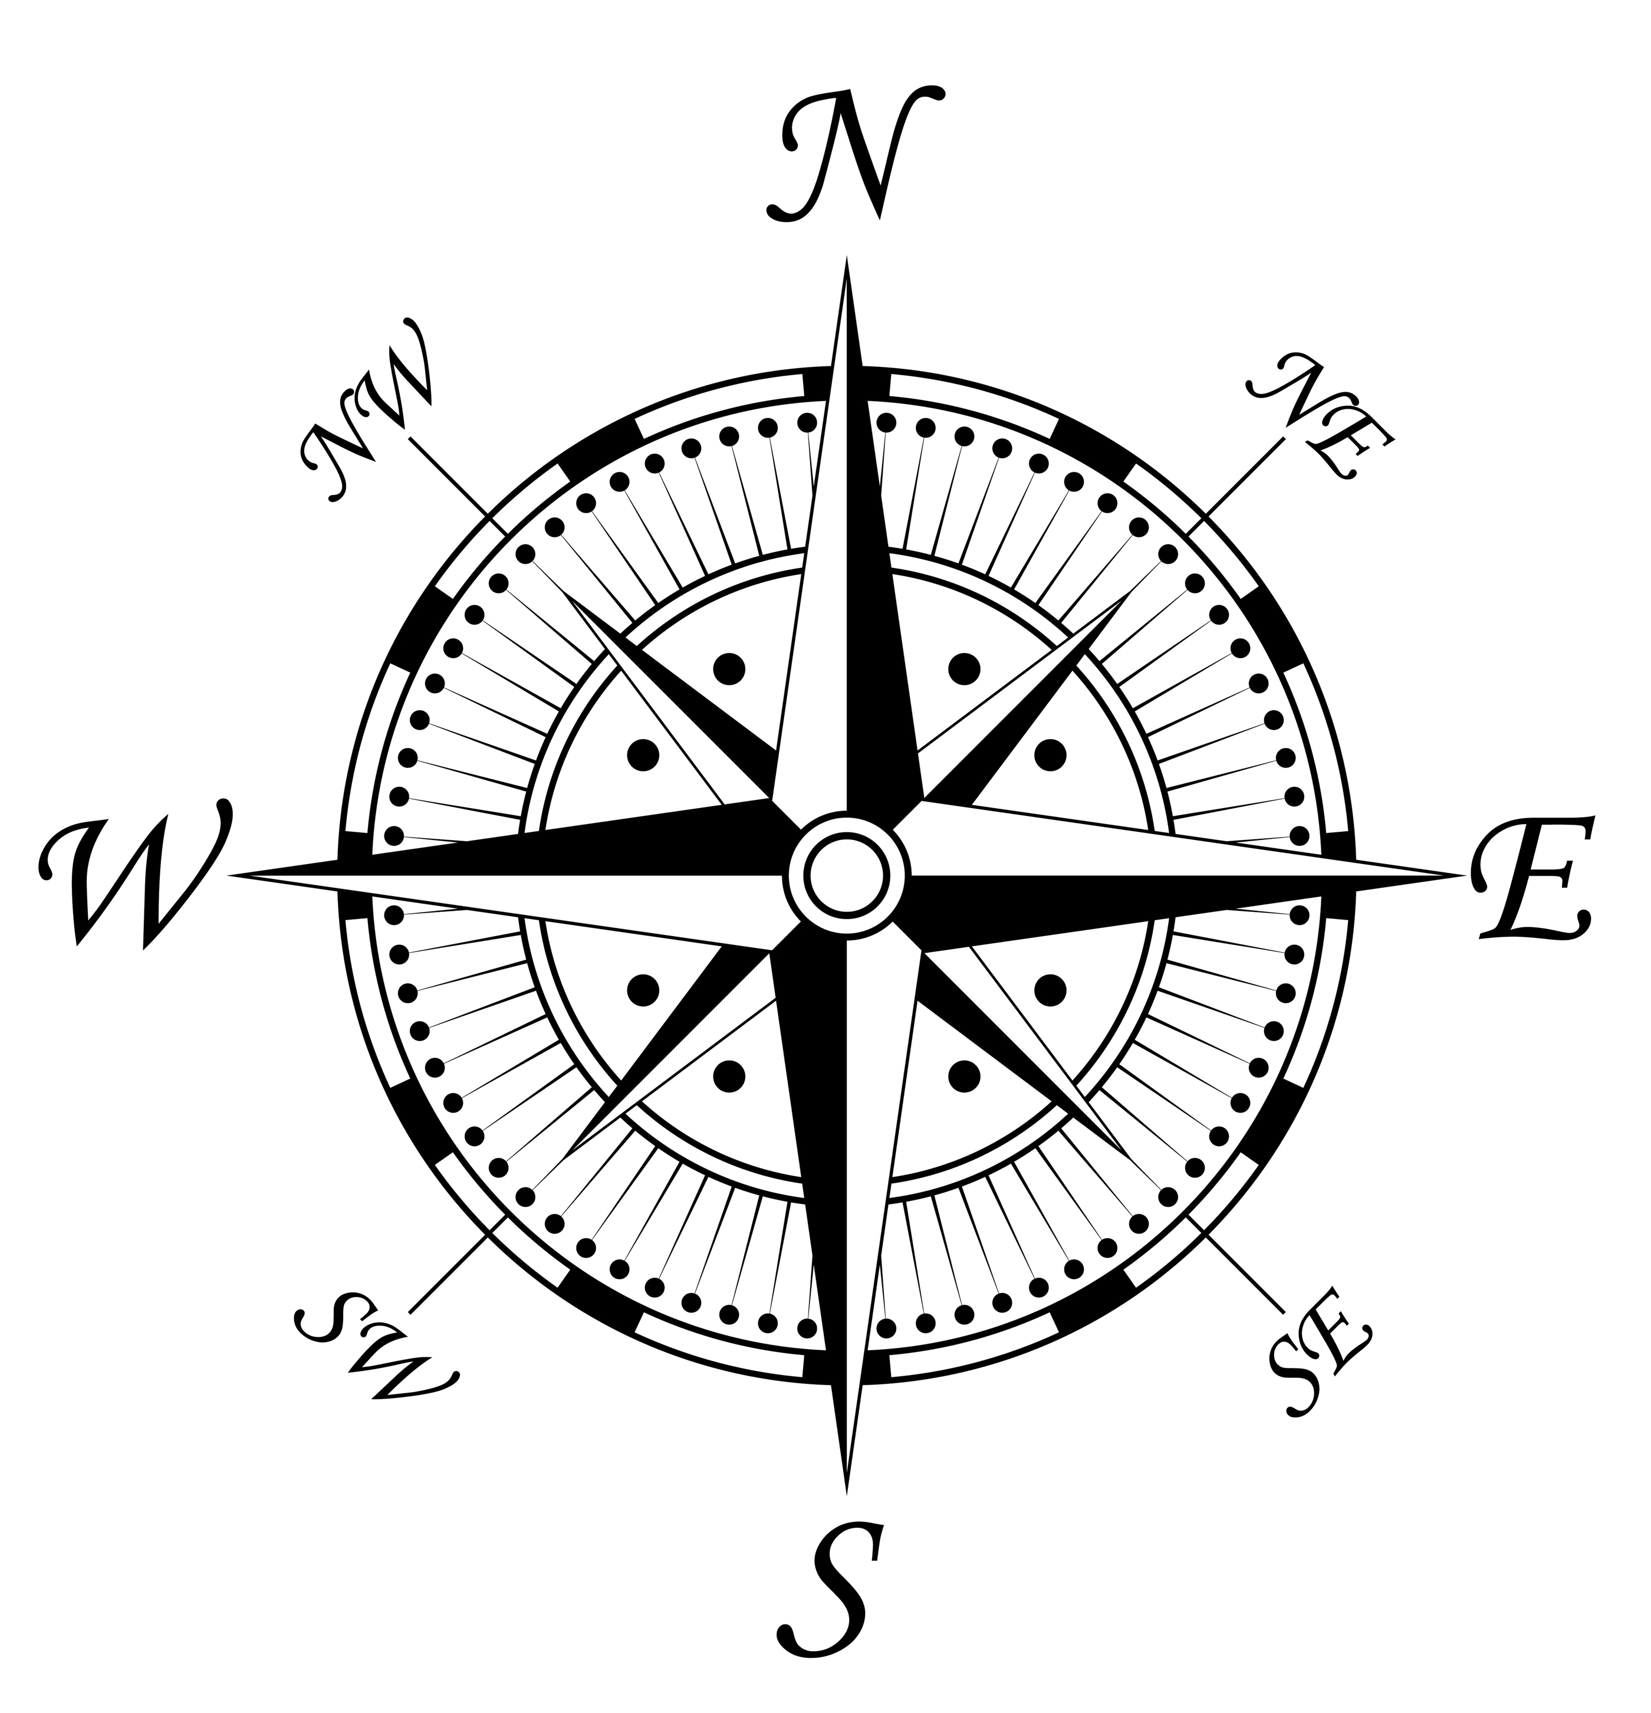

PAIR/GROUP OF 3 #1

- Find group 6 and together draw a line from North to South through the centre (middle) of both of your pieces of paper. Name this road McDonald St.

- Find group 2, 3, 4, and 5 and together draw a line that crosses the centre of each of your pieces of paper from West to East. Name this street Wallace St. It should be 80 cm in length.

- How long is McDonald St. in cm’s?

- How long is Wallace St. in cm’s?

- Draw another street half the length of McDonald St. through your square (this will be a dead end street). Name it with your partner!

__________________________ St.

Lenth_____________________________

- We placed the stop signs every _______ cm’s along our roads.

- We placed the speed bumps every ______ cm’s along our road.

- Place a tree every 20 cm’s along Wallace St.

PAIR/GROUP OF 3 #2

- Find group 7 and together draw a line from North to South through the centre (middle) of both of your pieces of paper. Name this road Elliott St.

- Find group 1, 3, 4, and 5 and together draw a line that crosses the centre of each of your pieces of paper from West to East. Name this street Wallace St. It should be 80 cm’s in length.

- How long is Elliott St. in cm’s?

- How long is Wallace St. in cm’s?

- Draw another street half the length of Elliott St. through your square (this will be a dead end street). Name it with your partner!

__________________________ St.

Lenth_____________________________

- We placed the stop signs every _______ cm’s along our roads.

- We placed the speed bumps every ______ cm’s along our road.

- Place a tree every 20 cm’s Wallace St.

PAIR/GROUP OF 3 #3

- Find group 8 and together draw a line from North to South through the centre (middle) of both of your pieces of paper. Name this road Taylor St.

- Find group 1, 3, 4, and 5 and together draw a line that crosses the centre of each of your pieces of paper from West to East. Name this street Wallace St. It should be 80 cm’s in length.

- How long is Taylor St. in cm’s?

- How long is Wallace St. in cm’s?

- Draw another street half the length of Taylor St. through your square (this will be a dead end street). Name it with your partner!

__________________________ St.

Lenth_____________________________

- We placed the stop signs every _______ cm’s along our roads.

- We placed the speed bumps every ______ cm’s along our road.

- Place a tree every 20 cm’s Wallace St.

PAIR/GROUP OF 3 #4

- Find group 9 and together draw a line from North to South through the centre (middle) of both of your pieces of paper. Name this road Edgar St.

- Find group 1, 2, 3, and 5 and together draw a line that crosses the centre of each of your pieces of paper from West to East. Name this street Wallace St. It should be 80 com’s in length.

- How long is Edgar St. in cm’s?

- How long is Wallace St. in cm’s?

- Draw another street half the length of Edgar St. through your square (this will be a dead end street). Name it with your partner!

__________________________ St.

Lenth_____________________________

- We placed the stop signs every _______ cm’s along our roads.

- We placed the speed bumps every ______ cm’s along our road.

- Place a tree every 20 cm’s Wallace St.

PAIR/GROUP OF 3 #5

- Find group 10 and together draw a line from North to South through the centre (middle) of both of your pieces of paper. Name this road Cook St.

- Find group 1, 3, 4, and 5 and together draw a line that crosses the centre of each of your pieces of paper from West to East. Name this street Wallace St. It should be 80 com in length.

- How long is Cook St. in cm’s?

- How long is Wallace St. in cm’s?

- Draw another street half the length of Cook St. through your square (this will be a dead end street). Name it with your partner!

__________________________ St.

Lenth_____________________________

- We placed the stop signs every _______ cm’s along our roads.

- We placed the speed bumps every ______ cm’s along our road.

- Place a tree every 20 cm’s Wallace St.

PAIR/GROUP OF 3 #6

- Find group 1 and together draw a line from North to South through the centre (middle) of both of your pieces of paper. Name this road McDonald St.

- Find group 7, 8, 9 and 10 and together draw a line that crosses the centre of each of your pieces of paper from West to East. Name this street Lewis St. It should be 80 cm’s in length.

- How long is McDonald St. in cm’s?

- How long is Lewis St. in cm’s?

- Draw another street half the length of McDonald St. through your square (this will be a dead end street). Name it with your partner!

__________________________ St.

Lenth_____________________________

- We placed the stop signs every _______ cm’s along our roads.

- We placed the speed bumps every ______ cm’s along our road.

- Place a tree every 20 cm’s Wallace St.

PAIR/GROUP OF 3 #7

- Find group 2 and together draw a line from North to South through the centre (middle) of both of your pieces of paper. Name this road Elliott St.

- Find group 6, 8, 9 and 10 and together draw a line that crosses the centre of each of your pieces of paper from West to East. Name this street Lewis St. It should be 80 cm’s in length.

- How long is Elliott St. in cm’s?

- How long is Lewis St. in cm’s?

- Draw another street half the length of Elliott St. through your square (this will be a dead end street). Name it with your partner!

__________________________ St.

Lenth_____________________________

- We placed the stop signs every _______ cm’s along our roads.

- We placed the speed bumps every ______ cm’s along our road.

- Place a tree every 20 cm’s Wallace St.

PAIR/GROUP OF 3 #8

- Find group 3 and together draw a line from North to South through the centre (middle) of both of your pieces of paper. Name this road Taylor St.

- Find group 6, 7, 9 and 10 and together draw a line that crosses the centre of each of your pieces of paper from West to East. Name this street Lewis St. It should be 80 cm’s in length.

- How long is Taylor St. in cm’s?

- How long is Lewis St. in cm’s?

- Draw another street half the length of Taylor St. through your square (this will be a dead end street). Name it with your partner!

__________________________ St.

Lenth_____________________________

- We placed the stop signs every _______ cm’s along our roads.

- We placed the speed bumps every ______ cm’s along our road.

- Place a tree every 20 cm’s Wallace St.

PAIR/GROUP OF 3 #9

- Find group 1 and together draw a line from North to South through the centre (middle) of both of your pieces of paper. Name this road Edgar St.

- Find group 6, 7, 8 and 10 and together draw a line that crosses the centre of each of your pieces of paper from West to East. Name this street Lewis St. It should be 80 cm’s in length.

- How long is Edgar St. in cm’s?

- How long is Lewis St. in cm’s?

- Draw another street half the length of Edgar St. through your square (this will be a dead end street). Name it with your partner!

__________________________ St.

Lenth_____________________________

- We placed the stop signs every _______ cm’s along our roads.

- We placed the speed bumps every ______ cm’s along our road.

- Place a tree every 20 cm’s Wallace St.

PAIR/GROUP OF 3 #10

- Find group 1 and together draw a line from North to South through the centre (middle) of both of your pieces of paper. Name this road Cook St.

- Find group 6, 7, 8, and 9 and together draw a line that crosses the centre of each of your pieces of paper from West to East. Name this street Lewis St. It should be 80 cm’s in length.

- How long is Cook St. in cm’s?

- How long is Lewis St. in cm’s?

- Draw another street half the length of McDonald St. through your square (this will be a dead end street). Name it with your partner!

__________________________ St.

Lenth_____________________________

- We placed the stop signs every _______ cm’s along our roads.

- We placed the speed bumps every ______ cm’s along our road.

- Place a tree every 20 cm’s Wallace St.






Content: (Topic)  This is Lesson two of a three part lesson in which the students will construct a 2D town on large sheets of graphing paper through using mathematical instructions. | Instructional Strategies: (Specific)  -Circulate  -Ask guiding questions  -Encourage dialogue between peers and pairs
Outcomes:  Outcome: SS5.1  Design and construct different rectangles given either perimeter or area, or both (whole numbers), and draw conclusions. [C, CN, PS, V] | Indicators:  a. Construct (concretely or pictorially) and record the dimensions of two or more rectangles with a specified perimeter and select, with justification, the dimensions that would be most appropriate in a particular situation (e.g., a rectangle is to have a perimeter of 18 units, what are the dimensions of the possible rectangles, which rectangle would be most appropriate if the rectangle is to be the base of a shoe box or a dog pen).
Prerequisite Learning:
-Some knowledge of area (how to calculate the area of a 2D object/length and width), dimensions, ability to measure and use a ruler, problem-solving skills, division and multiplication skills.

Preparation: (Equipment/materials/set-up)
-Same graphing paper from lesson I, with the roads the children have drawn on them, placed on the ground in the centre of the classroom again (same as in lesson I) *(52cmx80cm)
-Students into pairs as in lesson I
-Worksheet for each pair with instructions to construct rectangles of certain areas which will represent buildings (each pair will have a sheet with different buildings that they must construct) (1-10)

Set (5 min)  -Have students get back into their pair groupings from the previous lesson during which they constructed roads  -Hand out the instructions to each pair/group of 3  -Tell them that they will now be adding buildings to their town  Development (30 min)  -Have the students plot their buildings on the chart paper  Closure (5 min)  -Have the students stand back and admire their town, small class discussion about how they think it is coming along, what we may need to add etc. | Student Engagement/Classroom Management Strategies  -Circulate to ensure everyone understands/is on task

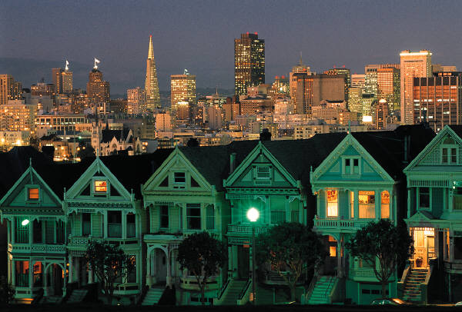
Buildings!
Group 1:
- Draw a church that is 12cm by 10cm along Wallace St.

- Draw a hospital that has an area of 200cm2 along McDonald St.

- Draw a house along the street that you created and record its dimensions

_______cm by _________cm

_____________________cm2

Why did you choose these dimensions for your house? (explain)

*Colour and decorate your buildings as you wish! Be creative!

Buildings!
Group 2:
- Draw a bank that is 12cm by 10cm along Wallace St.

- Draw a library that has an area of 100cm2 along Elliott St.

- Draw a house along the street that you created and record its dimensions

_______cm by _________cm

_____________________cm2

Why did you choose these dimensions for your house? (explain)

*Colour and decorate your buildings as you wish! Be creative!

Buildings!
Group 3:
- Draw a cafe that is 9cm by 9cm along Wallace St.

- Draw a College that has an area of 150cm2 along Taylor St.

- Draw a house along the street that you created and record its dimensions

_______cm by _________cm

_____________________cm2

Why did you choose these dimensions for your house? (explain)

*Colour and decorate your buildings as you wish! Be creative!

Buildings!
Group 4:
- Draw a temple that is 8cm by 10cm along Wallace St.

- Draw a Soccer field that has an area of 100cm2 along Edgar St.

- Draw a house along the street that you created and record its dimensions

_______cm by _________cm

_____________________cm2

Why did you choose these dimensions for your house? (explain)

*Colour and decorate your buildings as you wish! Be creative!
Buildings!
Group 5:
- Draw a park that is 15cm by 10cm along Wallace St.

- Draw an apartment building that has an area of 80cm2 along Cook St.

- Draw a house along the street that you created and record its dimensions

_______cm by _________cm

_____________________cm2

Why did you choose these dimensions for your house? (explain)

*Colour and decorate your buildings as you wish! Be creative!

Buildings!
Group 6:
- Draw a dance studio that is 10cm by 8cm along Lewis St.

- Draw a University that has an area of 200cm2 along McDonald St.

- Draw a house along the street that you created and record its dimensions

_______cm by _________cm

_____________________cm2

Why did you choose these dimensions for your house? (explain)

*Colour and decorate your buildings as you wish! Be creative!

Buildings!
Group 7:
- Draw a car lot that is 15cm by 10cm along Lewis St.

- Draw a clothing store that has an area of 80cm2 along Elliott St.

- Draw a house along the street that you created and record its dimensions

_______cm by _________cm

_____________________cm2

Why did you choose these dimensions for your house? (explain)

*Colour and decorate your buildings as you wish! Be creative!

Buildings!
Group 8:
- Draw a restaurant that is 8cm by 10cm along Lewis St.

- Draw a hospital that has an area of 200cm2 along Taylor St.

- Draw a house along the street that you created and record its dimensions

_______cm by _________cm

_____________________cm2

Why did you choose these dimensions for your house? (explain)

*Colour and decorate your buildings as you wish! Be creative!

Buildings!
Group 9:
- Draw a garden that is 10cm by 12cm along Lewis St.

- Draw a swimming pool that has an area of 100cm2 along Edgar St.

- Draw a house along the street that you created and record its dimensions

_______cm by _________cm

_____________________cm2

Why did you choose these dimensions for your house? (explain)

*Colour and decorate your buildings as you wish! Be creative!
Buildings!
Group 10:
- Draw tennis courts that are 12cm by 10cm along Lewis St.

- Draw a bakery building that has an area of 80cm2 along Cook St.

- Draw a house along the street that you created and record its dimensions

_______cm by _________cm

_____________________cm2

Why did you choose these dimensions for your house? (explain)

*Colour and decorate your buildings as you wish! Be creative!

Content: (Topic)  This is Lesson two of a three part lesson in which the students will construct a 2D town on large sheets of graphing paper through using mathematical instructions. | Instructional Strategies: (Specific)  -Circulate  -Ask guiding questions  -Encourage dialogue between peers and pairs
Outcome: SS5.5  Describe and provide examples of edges and faces of 3-D objects, and sides of 2-D shapes that are:  - parallel  - intersecting  - perpendicular  - vertical  - horizontal. | Indicators:  Sketch a 2-D shape or 3-D object that is relevant to self, family, or others and identify any lines, edges, or faces that are parallel, intersecting, perpendicular, vertical, or horizontal.
Prerequisite Learning:
•Familiarity shapes and their attributes
•Spatial awareness

Preparation: (Equipment/materials/set-up)
•Rulers (each student should have one)
•Large sheets of graphing paper
•Instruction sheets for each pair (see attached)
•The town they have constructed on graphing paper laid out on the floor in the centre of the classroom
•Loose leaf paper (several sheets) to sketch and jot down notes on to hand in

Set (5 min)  -Discuss with the class what the definition of parallel lines, intersecting lines, perpendicular lines, vertical lines, and horizontal lines look like.  -Write definitions for each on the board (with an accompanying picture)  Parallel: In geometry, parallel lines are lines in a plane, which do not meet; that is, two lines in a plane that do not intersect or touch each other at any point are said to be parallel.  Intersecting Lines: Intersecting lines are two lines that share exactly one point. This shared point is called the point of intersection. Although we're dealing specifically with lines in this lesson, line segments also intersect where they share a common point.  Perpendicular lines: Lines that are at right angles (90°) to each other.  Vertical lines: A vertical line is one the goes straight up and down, parallel to the y-axis of the coordinate plane. All points on the line will have the same x-coordinate. In the figure above, drag either point and note that the line is vertical when they both have the same x-coordinate. A vertical line has no slope.  Horizontal lines: A horizontal line is a straight, flat line that goes from left to right. Given a function (i.e. from the real numbers to the real numbers), we can decide if it is injective by looking at horizontal lines that intersect the function's graph.  Development (30 min)  -Have the students explore their town and find these concepts within it, have them write the location (general) and draw a quick sketch  Closure (5 min)  -After they have completed their task ask them to share the places they found these types of lines in a class/group discussion | Student Engagement/Classroom Management Strategies  -Circulate to ensure everyone understands task/is on task

Lesson I

Learning Goals:

-Become comfortable using a ruler, making measurements, recording measurements, and choosing appropriate measurements for specific objectives.

-Linking the real life practical uses of measurement to the concept, understanding their environment, plotting roads and stop signs etc. exploring the real life application of math through map making.

-Developing spatial awareness and the ability to use and create simple maps.

Questions to ask:

How did you figure out the length for your own personal street that you and your group drew? Explain your strategy.

How did you and the other groups coordinate to draw Wallace St./Lewis St. together?

How did you come up with the entire length of the N/S St. that you and the other group drew together? Explain your strategy.

What method did you use to measure the streets? Explain your strategy.

How did you decide how far apart the stop signs and speed bumps should be? What criteria did you use? Did you base your spacing on street signs that you have seen in real life? How so?

Anticipation of errors:

-Have students call you over before they begin plotting their lines on the map and show you their work, ask them to explain their rationale, what they did to reach it, and hopefully this should help them to catch any errors they may have made and correct them before plotting their roads.

-Have students use pencil when plotting their roads originally and stand back and review what they have done with the groups around them, again this should help them to catch and change any errors that they may have made.

-Have the whole class stand back, look at the town, discuss any changes they think should be made etc. before having the students finalize the town (draw on roads permanently/glue on stop signs etc. permanently).

Monitoring:
*See attached chart.

Connections:
-Glance over monitoring chart and have two pairs who used different strategies to calculate the length that their own street should be to share their strategies with the class.

-Do the same with measurement techniques.

-On my map I would have seen that the trees are 20 cms apart and there are less stop signs than trees along roads usually so I tripled this number and put my stop signs every 60 cm.
What did you do?

Lesson II

Learning Goals:

-Become comfortable drawing 2 D objects using given measurements

-Linking the real life practical uses of measurement to the concept, understanding their environment, plotting buildings etc. exploring the real life application of math.

-Developing spatial awareness and the ability to use and create simple maps.

-Taking a given area and breaking it down into separate measurements/creating 2 D drawings by using a given area

Questions to ask:

How did you figure out the length for the sides of your buildings using the area given? Explain your strategy.

How did you use the measurements given to create a building?

How did you decide where to place your buildings on the map? What criteria did you use?

Why did you decide to make your house the size that you did? Did the sizes of the other buildings factor into your decision making process? How so?

Anticipation of errors:

-Have students call you over before they begin drawing their 2 D buildings and show you their work, ask them to explain their rationale and what they did to reach their answers, hopefully this should help them to catch any errors and correct them before drawing their buildings on the map.

-Have students use pencil when plotting their buildings originally and then stand back and review what they have done with the groups around them, again this should help them to catch and change any errors they may have made.

-Have the whole class stand back, look at the town, discuss any changes they think should be made etc. before having the students finalize the town (draw on buildings permanently).

Monitoring:
*See attached chart.

Connections:
-Glance over the monitoring chart and have two pairs who used different strategies to calculate the lengths to the sides of their buildings using the given area share their strategies.

-Do the same with buildings drawn using given lengths.

-Houses are usually smaller than Universities and shopping malls, so I would have made my house 1/3 of the size of one of these types of buildings. What strategies did you use to determine your house size? (have the class share their rationales to their house sizes).

Lesson II

Learning Goals:

-Become comfortable with the concept of different sorts of lines (vertical, horizontal etc.) and be able to identify them in real life environments.

-Developing spatial awareness.

Questions to ask:

What was your strategy for finding lines on the map?

Where did you find different sorts of lines?

Did any of the lines function as two different types of lines? Explain.

Monitoring:
*See attached chart.

Connections:
-Have students share all of the different areas where they were able to locate the different types of lines. Have everyone share in a class discussion, compare, contrast and learn from each other’s answers.

