Themed Tasks:
Outcome N1.8

Annamarie Cressman
200 338 487
Professor Gale Russell
EMTH 310
November 26th, 2015

Outcome: N1.8
Identify the number, up to 20, that is one more, two more, one less, and two less than a given number.

Theme: Seasons to coincide with the grade 1 science unit of seasons. This lesson focuses on an autumn theme.

Learning Goals:
- Building number sense regarding the relationship between numbers (one more, two more, one less, two less).
- Students being able to recognize a number that is one more, two more, one less, and two less than a given number using mental math.
- Identify the pattern for recreating one more, two more, one less, two less

Materials: small pumpkin objects, bats or any other fall/halloween related items that are appropriate, small buckets, pieces of paper with ten-frames, more/less/same attached cards, 100 chart.

Task/Problem/Question: Adapted from Van de Walle et. al. (2015)
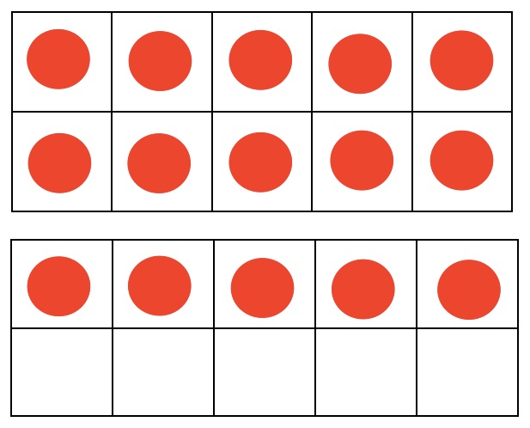
Using a ten-frame cards with 2-20 written on cards (so 18 cards total) represented on them, have students take a card and then take a more/less/same card. Students then have to create their own representation of the new number that will result. Representations can be done with a ten-frame, or with any of the provided manipulatives.

1) Show a ten frame with numbers between 2-20 From preferably using pumpkins instead of dots. google
images

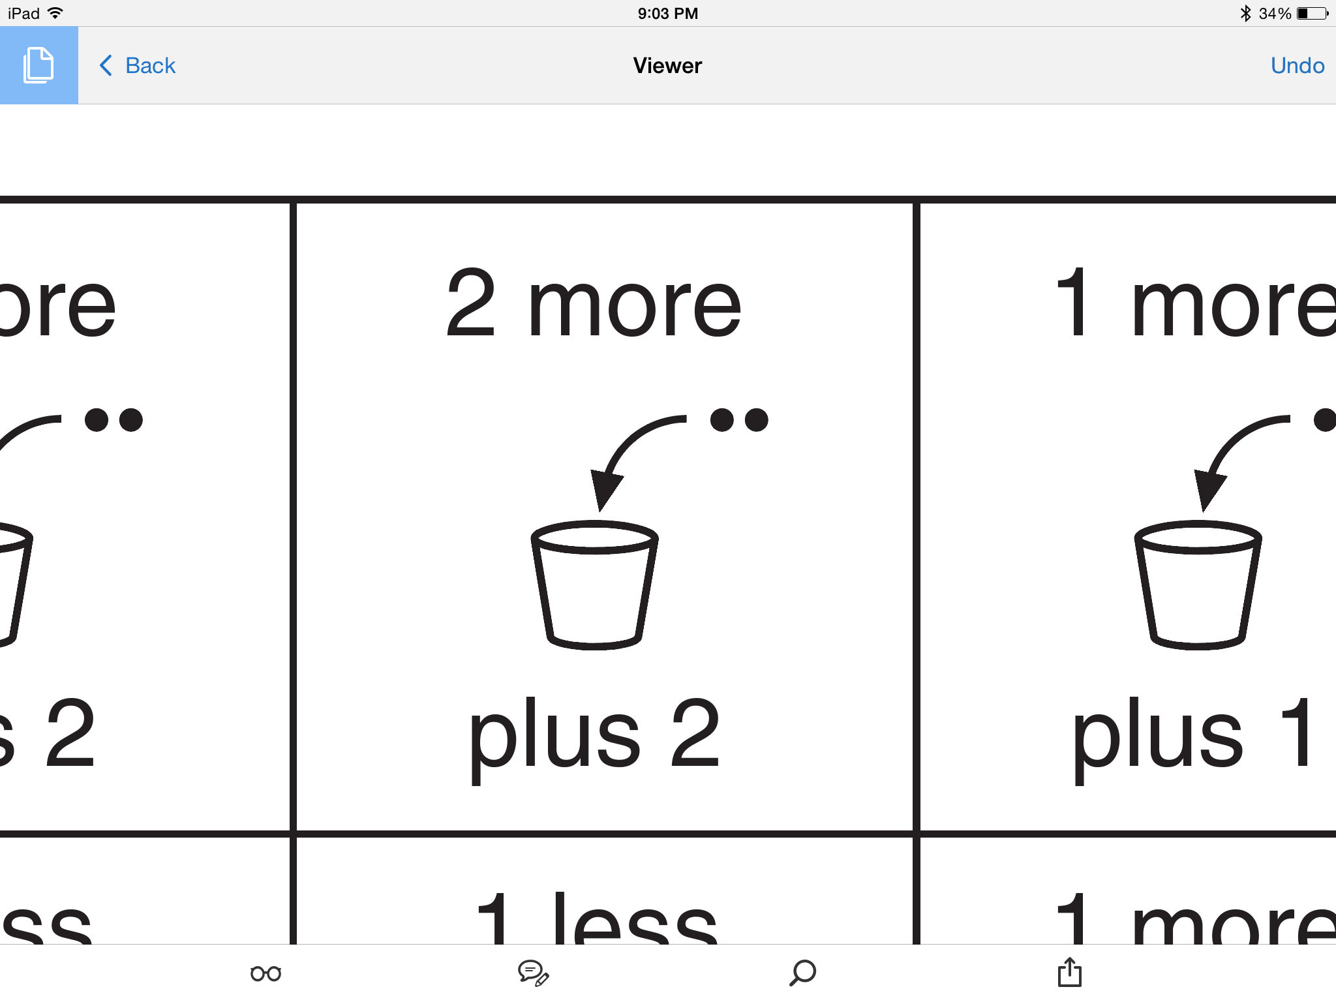

2) draw a card such as this: From google
images

3) Students create their own representation of the answer

Adaptation: Students could also put the same number of manipulatives, as represented on the first card, and put these objects into a small pail. After drawing the more, less or same card, then students have add, pull out or leave the same. Students then guess how many objects are left and then proceed to count the actual amount.

Alternative 1: Students are given a number from 2-20 that is shown as pumpkins in a garden patch. On a piece of paper, students can use pumpkin manipulatives to represent one more, two more, one less or two less than the given number.

Anticipation:
- How might the students solve it?
  - Students might count out the original number using the manipulatives provided and then take away/add/keep the same according to the action card that is drawn. Similarly, they might draw out the number given.
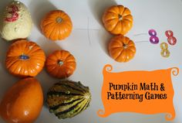
Questions to ask: How did you get that number of _____(object being used)? What are you counting by? How can you check that you have the correct number? (answer could include using a ten-frame to keep track, groupings of numbers in a certain way to count faster). How could you count differently?

From google images

  - Students might use a ten-frame to draw or put objects on
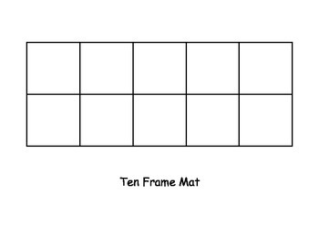
Questions to ask: Why do you like using the ten-frame? How does using the ten-frame help you?

From google images

  - Students might use a hundreds chart to count the more or less
Questions to ask: How are you counting with the chart? Can you show me? How do you find out your answer? (the more or less)
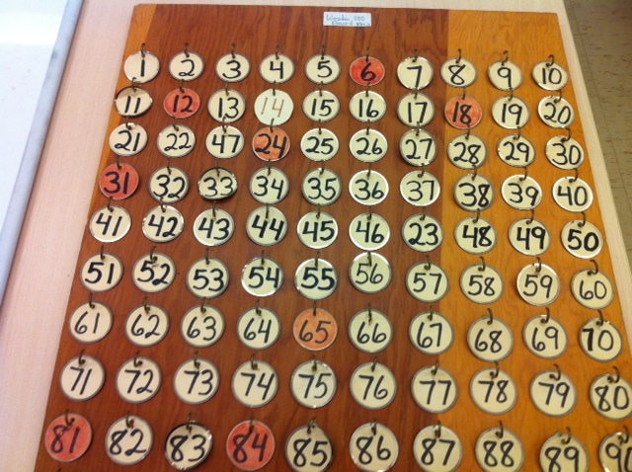
  - Students might count on their fingers
Questions to ask: What is your favourite reason for using your fingers? How do you keep track when the number is bigger than 10? What is another way that you could count that can be bigger than 10? (answers could include using manipulative, 10-frame, or 100 chart)
  - Students might count in their heads
Questions to ask: How do you keep track of the number being counted? Are you getting the right answer after the less or more card is drawn? What are you counting by? Do you need to use your fingers to help keep track?
  - Students might count using the numbers on a clock
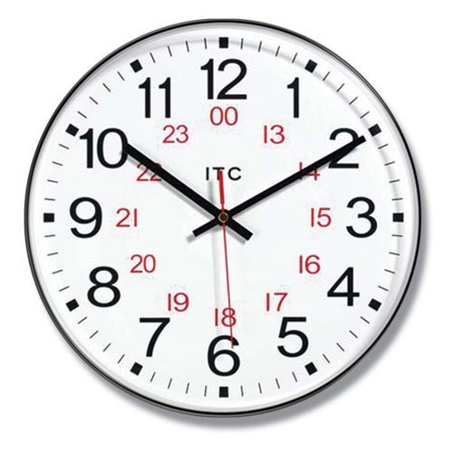
Questions to ask: How did you come up with this idea? How does it help you? How do you count when the number is being than 12? (or 24 with a 24 hour clock).

From google images

  - Students might use a number line
Questions to ask: How are you counting on the line? Can you show me? Why do you like this chart? How do you get your final answer when the more or less card is drawn?
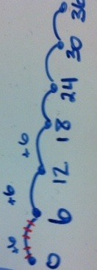

B. Anticipation of errors
- Students might lose track of their counting with certain methods of counting such as counting in their head or using fingers.
Questions to ask: What could you do differently to help you keep track of the numbers? Is there anything in the room that can help you?
- Students might consistently not add or take away the correct number as indicated on the more/less/stay the same card.
Questions to ask: How can we keep track of our numbers? What happens if we bring in one more? Two more? Can you show me? What does it mean to stay the same? What does one less look like?
- Confusion between more and less
Questions to ask: What happens if we bring in one more? Two more? Can you show me? What does it mean to stay the same? What does one less look like? Try to use language that is different to more/less such as bring in or take away and see if the child responds better to different language. Make sure the child can see the symbols on the more/less/same cards to see if that helps them.

Monitoring
Counting manipulatives or drawing
Ten-frame
Hundreds Chart
Fingers
Counting in Head
Counting with clock
Counting on a number line
Other:
Other:

Additional Comments:

Selecting and Sequencing:
- Start with something broad and show (or practice) options for representing their work. With the whole class: to start perhaps have a picture of a tree without leaves and add leaves to the tree to represent the original number. Then draw a more/less/same card and have the class decide what needs to happen with the leaves.
- Then the teacher could move to different approaches as the class appears ready or allow the students to experiment with the different materials that you have outlined could be helpful.
An optional progression for introducing strategies could include: counting up, using manipulatives, using a number line, on a ten-frame.
- If there is confusion about different approaches then the teacher could clarify by going through demonstrations with the students to show them different ways of solving their problems.

Connections:
Connecting class work to the learning goals. Questions we ask to help students see the connections between the different learning styles. Student's answers should reflect that students understand the learning goals
- A closure game if the teacher chooses: Play a game with the whole class where we pull a numeral and put that number of apples into a large bucket. Then pull a same/less/more card and have a students add or take away the amount of apples. The whole class now has to choose how many apples they think are in the bucket. The whole class can count the apples remaining in the bucket.
- Who can tell me a pattern that happens with our game? What are the options for our cards? (1 more, 2 more, 1 less, 2 less, same).
- What are some ways that you (students) found the answers? (have some students share their strategies)
- Assess student connections: Who has done adding and subtraction?
- How is this similar to adding and subtraction? How do we know?

Van de Walle, J. A., Karp, K. S., Bay-Williams, J. M., McGarvey, L. M., & Folk, S . (2015). Elementary and Middle School Mathematics: Teaching Developmentally (Fourth Canadian Edition). Toronto, ON: Pearson

Handouts from Van de Walle et. al. (2015) found at: http://wps.ablongman.com/ab_vandewalle_math_6/0,12312,3547876-,00.html

