Themed Tasks:
Outcome P1.3

Annamarie Cressman
200 338 487
Professor Gale Russell
EMTH 310
November 26th, 2015

Outcome:
Outcome P1.3: Describe equally as a balanced and inequality, concretely, physically, and pictorially (0-20)

Theme: Seasons to coincide with the grade 1 science unit of seasons. This lesson focuses on a winter theme.

Learning Goals: For students to communicate an understanding equality (balance) and inequality (unbalanced).

Materials: Create 5-6 stations using the following ideas or other ideas that help represent balance:
- Geometry shapes (templates for balance/symmetry could be provided at the teacher's discretion)
- Balance scales, small winter related and equally weighed manipulatives to fit on scales (snowflakes, polar bears, 'snow balls', snowmen, snowy owl). Here is a craft to create balance scales if more are wanted for these activities: http://lets-explore.net/blog/2012/02/hanger-balance/. This activity involves making balance scales out of a coat hanger, yarn and paper cups.
- Two "igloos" (can be the floor taped in the shape of igloo) where students can demonstrate balance or equality with student bodies. Consider educating on any cultural significance that may be associated igloos. "Snow forts" could also be used.
- Snack station where the group has to equally distribute a snack to all the members at the table. Before they eat, they have to tell the teacher why it is equal. The teacher can distribute the snack unequally to emphasize to the students the equal distribution is part of balance.
- Draw what a balance looks like in the balance scale worksheet.

Task/Problem/Question:
How many ways can you find or create balance or equal parts in the classroom?

Alternative 1: How many places can you find in the classroom that have balance? Students can observe balances that exist in the classroom and then discuss each and whether or not it is a balance.

Alternative 2: Each student can create a balance at 3 different stations.

Anticipation:
- How might students solve it?
  - At drawing table: students draw what a balance looks like in the picture provided.
Questions to ask: What did you draw in the scale? How do we know it is balanced? What might unbalanced look like?
  - Students could find any number of items in the classroom that demonstrate balance. This will vary from class to class.
Questions to ask: How do we know it is balanced? Please explain the balance to me.
  - At actual balance scale: students represent balance on a balance scale using manipulatives.
Questions to ask: How do we know it is balanced? What happens when you add one more to just one side? What can we call it when there is more on one side?
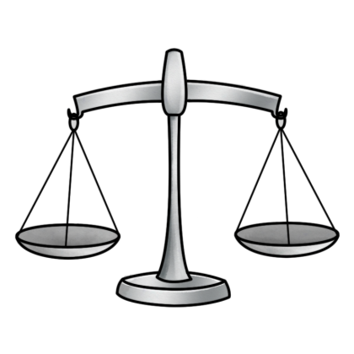
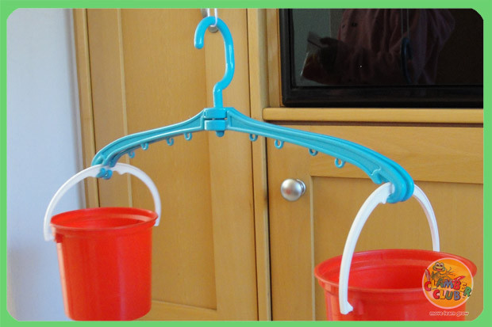

From google images

  - Students represent balance by having equal amounts of students in each igloo
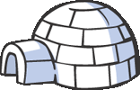
Questions to ask: How do we know when it is balanced? How many students are in each igloo? What happens if we take just one student out of one igloo? What would you call this? Is is balanced?

From google images

  - At snack table: students equally distribute the snack so that everyone has the same amount.
Questions to ask: How do we make the snack balanced or equal? What does unequal snack look like? How can we make sure that everyone has the same?
  - At geometry table: students create balance (possibly symmetry) with geometry pieces
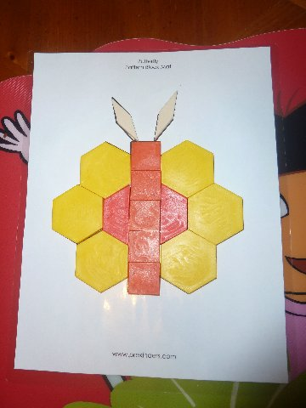
Questions to ask: How is this balanced? Can you describe it to me? Why did you make this shape?

From google images

B. Anticipation of errors
  - Students might not understand balance in the different contexts.
Questions to ask: What is balance? Can you show me on a scale? What can balance look like in _____ (another activity or situation). The teacher can try using different language such as equal to see if the child responds better to different vocabulary. The teacher could also allow the student to carry a picture of a balance that makes sense to them to allow the child to transfer the knowledge to different scenarios.
  - Students might think that they are suppose to create/find imbalance.
Teacher can redirect to the purpose of the task.
  - Students might not understand what a balance is.
Questions to ask: Using the example of a teeter totter, the the teacher could ask, "when might a teeter totter be balanced?" Using the example of the balance scale, ask the student to create what they think a balanced should look like.

Monitoring (lots of "other" spots because of the variety of responses available)
Draw Balance
Balance Scale
Igloo or snow fort
Snack
Geometry pieces
Other
Other
Other
Other
Additional comments:

Selecting and Sequencing:

  - Start by asking students about where they see balance in their daily lives.
  - Depending on the class and the teacher: It may work best to have students explore balance on their own and then talk about what they discovered OR the teacher may prefer to demonstrate what balance could look like at different stations and then allow the students to explore.
A possibility of sequencing for strategies could be going from
  - Allow students to demonstrate their findings starting with the most popular strategy.
  - Explore where else balance exists in the school and playground.
  - After exploring balance, students could practice creating and finding imbalance.

Connections:
Connecting class work to the learning goals. Questions we ask to help students see the connections between the different learning styles. Student's answers should reflect that students understand the learning goals.
- Who can tell me what a balance is?
- What are some examples of balance?
- What are some of the balances that we made?
- To lead students into further think:
  - What is does unbalanced look like?
  - How many different types of unbalance can there be?

