Themed Tasks:
Outcome SS1.2

Annamarie Cressman
200 338 487
Professor Gale Russell
EMTH 310
November 26th, 2015

Outcome:
Outcome: SS1.2
Sort 3-D objects and 2-D shapes using one attribute, and explain the sorting rule.

Learning Goals:
- Students should be able to classify 2-D and 3-D shapes in a way that makes sense to them.
- Learn that there are a variety of ways that shapes can be sorted.
- Learn to justify a reason for sorting

Theme: Seasons to coincide with the grade 1 science unit of seasons. This lesson focuses on a spring/summer theme or a camping theme.

Optional materials to include:
Geometry shapes: flat 2-D, a variety of 3-D shapes, trays for students to use for sorting (could be baskets, plates or any other way to help students organize). Take note of any shapes around the classroom that students could gather for their sorting. 2-D shapes should include hexagons, diamonds, triangles, kites, squares, rhombi. 3-D shapes should include cones, spheres, cylinders, cubes, pyramids, 3-D rectangles, 3-D hexagons.
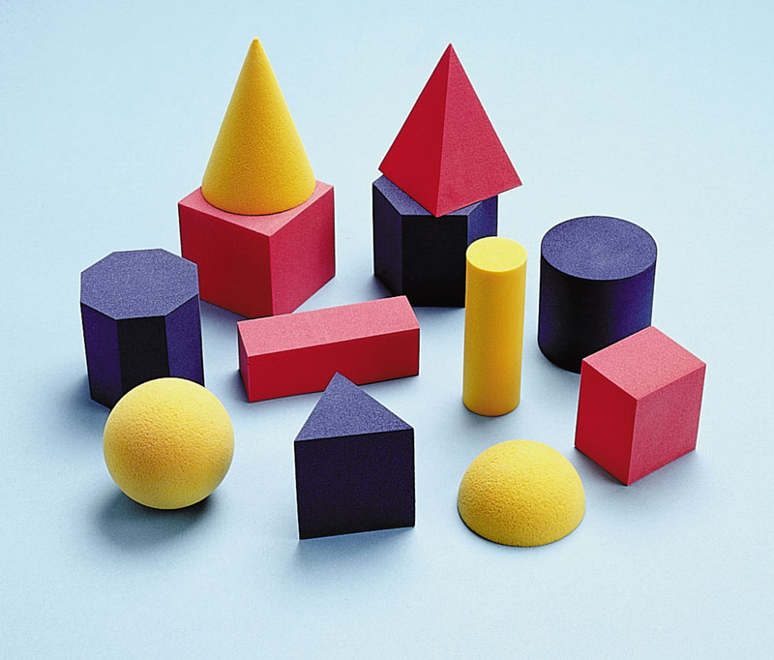
For alternative activities: To keep with the spring/summer theme, include objects that are about these seasons. Items could include: a kite, beachball, tent, small stop signs, picnic basket, leaves (shaped like a triangle maybe), rocks shaped like rhombi (or another shape), pylons (to represent soccer games), camping cup, camping plates, sleeping bag, picture of a tipi style fire pit, a small toy cabin, frisbee. These items could be set up as a camping set and the students could engage with the whole set.
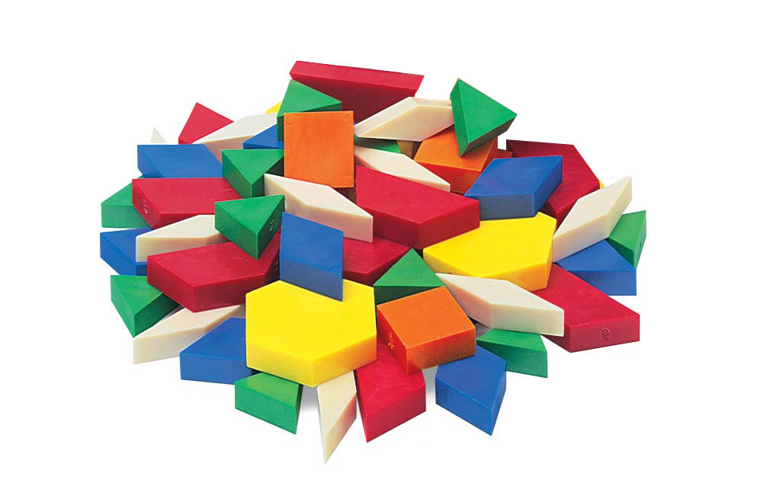
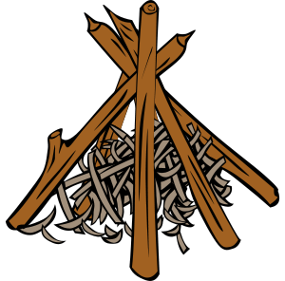

Task/Problem/Question:
Students can create a shape, using 2-D and 3-D shapes, that represents their favourite part of spring or summer. Students will then take apart their creation and sort, using their own method, the blocks they used into two groups. The teacher should take pictures of the sculptures.

Alternative 1: Given the materials listed above, ask students to find how many ways they can sort the shapes into two categories.

Alternative 2: Give students 2 sorting areas and ask for 2 ways to sort the shapes.

Alternative 3: "how many ways can you sort the shapes?"

Alternative 4: students identify how many spring/summer items are similar to geometric shapes.

Task/Problem/Question:
  - Combinations of student sorting might involve?
  - 4-sided 2-D shapes, non-4-sided 2-D shapes
Questions to ask: What did you create with your shapes? How did you sort your shapes? What about the 3-D shapes? How could we include those shapes?
  - 3-D shapes with sharp edges, 3-D shapes without edges
Questions to ask: What did you create with your shapes? How did you sort your shapes? Could you include the 2-D shapes? How else could you sort them?
  - short, tall
Questions to ask: What did you create with the shapes? How did you sort your shapes? Why did you choose this way? How else can you sort the shapes?
  - shaped like a house, not shaped like a house
Questions to ask: What did you create with your shapes? How did you sort your shapes? Why did you sort them like this?
  - shaped like a cup, not shaped like a cup
Questions to ask: What did you create with your shapes? How did you sort your shapes? Why did you sort them like this? Are there any shapes that don't have a place to go? How else could you sort them.
  - flat, not flat (2-D and 3-D)
Questions to ask: What did you create with your shapes? How did you sort your shapes? Why did you sort them like this? How else could you sort them.
  - can build tall, can build flat
Questions to ask: What did you create with your shapes? How did you sort your shapes? Why did you sort them like this? How else could you sort them?
  - rolls, doesn't roll
Questions to ask: What did you make with your shapes? How did you sort them now? Why did you sort them like this? How else could you sort them?

B. Anticipation of errors:
- Students might be confused about the expectations for the assignment.
Questions to ask: What is one way the shapes can be put into two groups? Can you think of another way?
b. Students might might be vague with their classification. (example: they may choose for all objects to be classified as a house)
Questions to ask: How are the objects all the same? How could they be different?
c. Students might create a classification that excludes certain shapes.
Questions to ask: How many shapes are in each of your spaces? Which shapes are left out? How could you sort the shapes that are left out? Could you put them with other shapes you sorted or should you make a new category?
d. Students might only sort two types of shapes (such as only squares in one and only spheres in another).
Questions to ask: How do you have your shapes sorted? Why did you choose this? How could we include the other shapes in the sorting? How could we include all of the shapes when sorting?

Monitoring:
4-sided 2-D shape and non-4-sided 2-D shape
3-D shapes with shape edges, 3-D shapes without sharp edges
short, tall
shaped like a house, not shaped like a house
shaped like a cup, not shaped like a cup
flat, not flat (2-D, 3-D)
can build tall, can build flat
rolls, doesn't roll
other
other

Selecting and Sequencing:
- Present the most common approach used by students then work towards least common.
- The teacher should integrate sorting methods that are similar but worded differently and discuss why they are similar.
- At the end of the lesson, have the students sort the blocks into 2-D and 3-D for putting away. Explain that is how we sort them for cleaning up and storing.

Connections:
Connecting class work to the learning goals. Questions we ask to help students see the connections between the different learning styles. Student's answers should reflect that students understand the learning goals
While students are working:
- How did you sort? Why did you choose this way? How else could you sort the shapes? What shapes are left out?
After students are done their sorting activities:
- How many ways can we sort 2-D and 3-D shapes? (many different ways)
- Why did you choose the way that you sorted them?
- Why should we sort shapes? (to give them names, to know where to put them away and where to find them)

